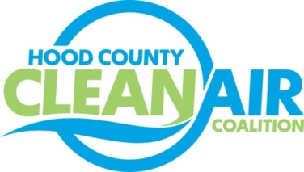
Meeting: Wednesday, January 9, 2019
Neely House
304 East Rucker Street, Granbury, Texas 76048
8:30-10:00 a.m.

Agenda

- Call Meeting to Order
- EPA Updates – Randy Pitre, EPA
- Local Updates – Michelle McKenzie
  - Review of December Meeting Summary
  - Review of Projects
    - Monthly Budget Review for November
    - Status of Projects
- Regional Updates – Michelle McKenzie
  - NCTCOG Submitted Comments on VW Settlement Funds Spending in DFW Area.https://www.nctcog.org/nctcg/media/Transportation/DocsMaps/Quality/Air/20181221_FinalPlanRecPriorities.pdf
  - Funding Opportunities: www.nctcog.org/aqfunding. Notable this Month: EPA National Clean Diesel Funding Assistance Program https://www.epa.gov/grants/clean-diesel-funding-assistance-program-fy-2019
- Other Discussion
- Adjourn

